Steps to download file from Application server

1. Go to SE38.Create a report with the below code.

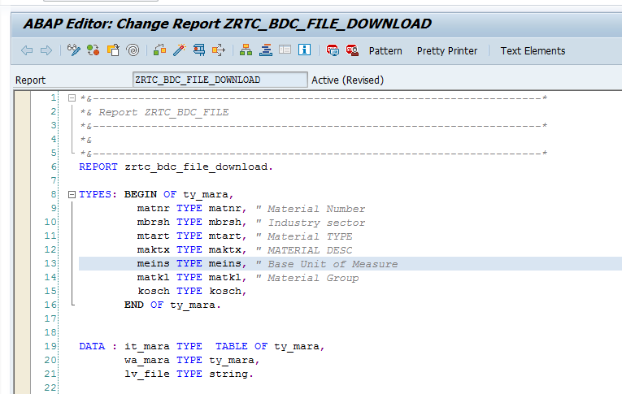

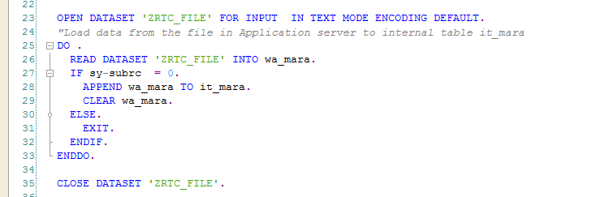

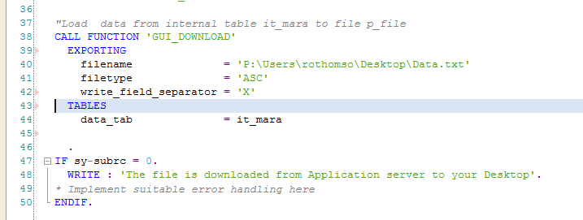

1. Create a blank text file Data.txt

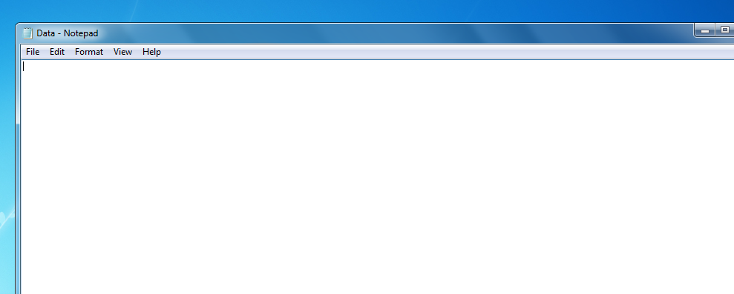

1. Save the file Data.txt on your local machine’s Desktop.
2. Execute the Report ZRTC_BDC_FILE_DOWNLOAD created in SE38.

Click on Allow.

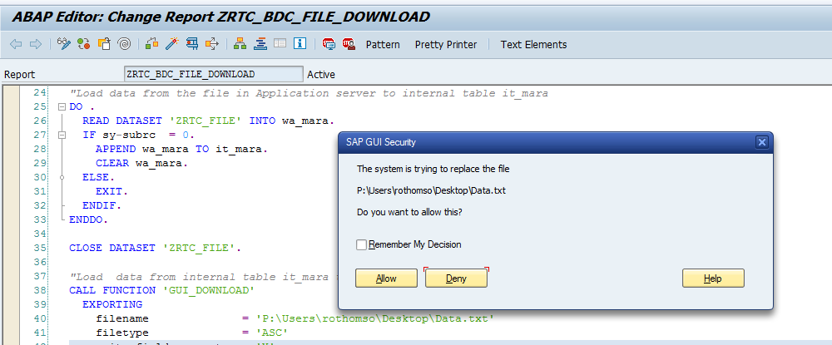

1. A message is displayed as follows indicating the file was downloaded successfully to your Desktop.

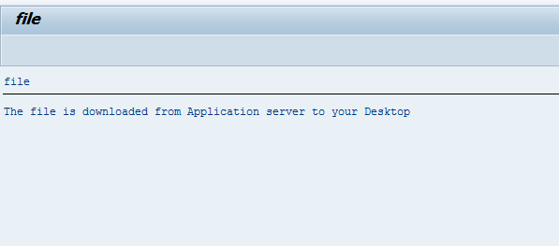

1. Check the file Data.txt on your Desktop.